Welcome to the Sunrise Mountain High School Basketball page.
We are a relatively new high school in Las Vegas. This is our eighth year in existence (2016-17). We average about 2400 students. We are located in the Northeast valley near Nellis Air Force base at the foot of the Sunrise Mountains. Our program has 3 teams, B, JV and varsity.
For 2017 season, there was once again a re-alignment in the conferences. We now compete in the 3A Division, the second largest division of high schools in Nevada. Our conference is the Sunset conference. There are 6 teams in our conference, the top four advances to the Regional playoffs.
Though we have yet to make it to the Regional playoffs in basketball, our student athletes and coaching staff return each year with a renewed passion and with a positive outlook for a fun and successful season.
As a coaching staff, we pride ourselves on putting graduation, and character development as a top priority. We really view our program and our school as “one big family”.
Academically, in 2015, Sunrise Mountain was recognized by Clark County School District as the high school with the greatest improvement of graduation rate in one year. Our former principal was recognized as the Nevada principal of the year and was recognized in Washington D.C.
Please take time to view our team video to get a glimpse of our program. As you can see, our athletes and coaches are passionate about our basketball program and our school.
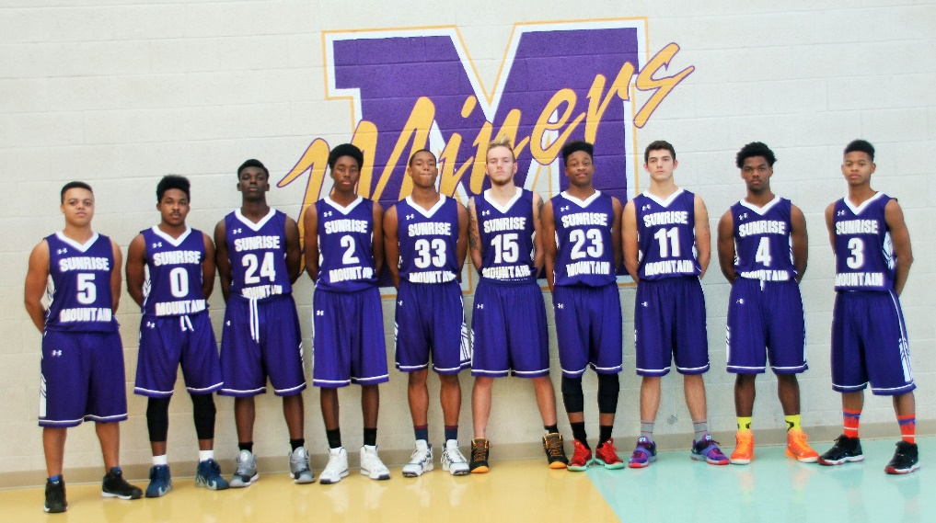
Thank you for visiting the Sunrise Mountain Basketball page.
Coach Teran
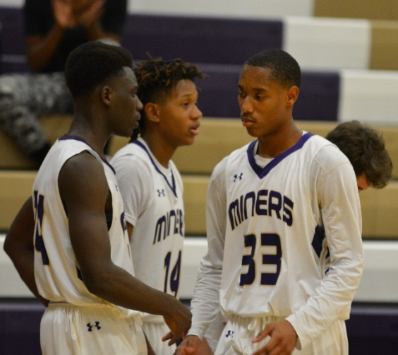
Head Coach

